***Administrative System***

**IMPLEMENTATION PLAN**

Version 1.0

17/12/2016

**VERSION HISTORY**

|  |  |  |  |
| --- | --- | --- | --- |
| **Version #** | **Implemented By** | **Revision Date** | **Comments** |
| 1.0 | *Yanik Blake* | *17/12/2015* | Original Version |
| 1.1 | *Yanik Blake* | 16/03/2016 | Revised Version |
|  |  |  |  |
|  |  |  |  |

Contents

Introduction 4

Purpose 4

System Overview 4

Assumptions and Constraints 4

Methodology 4

Performance 4

User Acceptance Testing 5

Train the User Training 5

Software Development Environment (SDE) 5

System Organization 5

Management Overview 6

Implementation Schedule 7

Security and Privacy 7

Implementation Support 8

Outstanding Issues 8

Risks and Contingencies 9

Implementation Verification and Validation 9

Acceptance Criteria 9

Project Implementation Plan Approval 10

## *Introduction*

## Purpose

The purpose of this plan is to outline the implementation strategy and specific activities for successful deployment of VTDI Administrative Application.

This is intended to be a working document which will be updated continuously in order to serve as a useful reference to project and Incident Management personnel.

## ****System Overview****

This module of the Administrative Management System will be an Inventory System for the Administrative staff of the Vocational Training Development Institute (Mandeville extension). This system will be design to maximize the staff’s productivity by providing effective structured environment which would otherwise have to be performed manually. By boosting the administrators work efficiency and production, the system will meet the users’ needs likewise remain easy to understand and use. More specifically, this system will be designed to allow the administrator to manage Inventory items.

## **Assumptions and Constraints**

The implementation of the project is based on the assumptions identified below.  If any of these assumptions are incorrect, then the Supervisor or Senior Manager reserves the right to make changes to the implementation for this project.

## Methodology

The project will be completed using tools and techniques prescribed by the Project Manager’s methodology.

## Performance

The traditional style of measuring performance, where users enter data into a screen, press enter or a function key wait for a response and measure the time to complete the function is no longer applicable for client/server applications.  In a client/server GUI environment each user/machine interaction results in some processing at one or more software servers.  Therefore, the process of entering a GUI screen and working on a GUI screen will typically result in many system transactions, most of which are transparent and unknown to the user.  Each of these transactions require the user to wait for a response and therefore each system interaction has a different set of response expectations by the user.

## User Acceptance Testing

The administrative staff of VTDI Mandeville will provide appropriate support from the project team to assist with the preparation and execution of the Acceptance Test.

## Train the User Training

The Administrative staff will agree upon a day to train users how to properly use the system as soon as each module is finished and accepted.

## Software Development Environment (SDE)

The software development environment will be confirmed during the Concept Definition stage and established during the Functional Design.  It consists of the necessary hardware and software tools required to develop and test the Administrative System.

## ****System Organization****

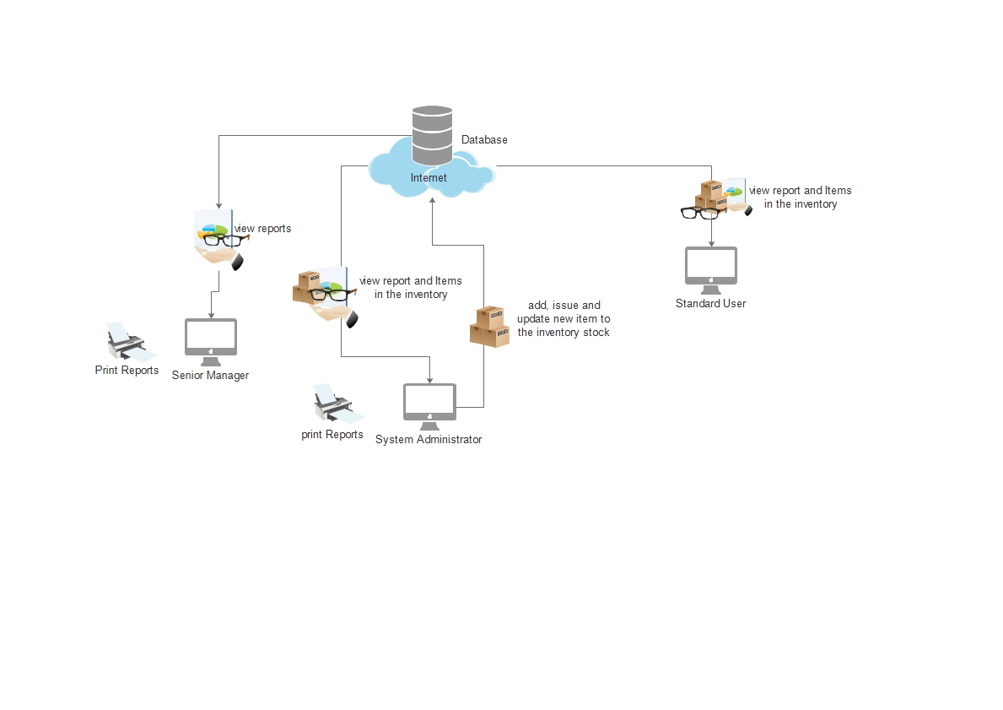

# 

## ****Management Overview****

Implementation of Administrative system will be accomplished by the Junior Software and User Interface developers, under the oversight of the Supervisor and Project Manager. The Project Manager has responsibility for the day-to-day activities of the Junior Software Developer and to ensure overall goals and timeframes are met. Primary responsibility for documentation, planning and preparation resides with the software developer and the User Interface (UI) Developer. The Project Manager has primary responsibility for accuracy of business requirements and ensuring that functionality meets or exceeds what is available in the administrative system. (See Section 2.2 Points of Contact for individual names).

**Points-of-Contact**

|  |  |  |
| --- | --- | --- |
| Role | **Name** | **Contact Number** |
| Supervisor | Dervan Hall |  |
| Project/Program Manager | Tyrone Maxwell |  |
| Junior User Interface Developer | Ramon Martin |  |
| Junior System Developer or System Maintainer | Yanik Blake |  |
| Database Administrator | Yanik Blake |  |
|  |  |  |

**Table 1.0– Points-of-Contact**

## 

## ****Implementation Schedule****

|  |  |  |
| --- | --- | --- |
| **Date** | **Action** | **Dependencies** |
| August 2015 | Training materials development begins | Requirements and Design complete |
| December 2015– January 2016 | User Acceptance testing | Field testing on incidents Scenario testing completed successfully |
| January 2016 | Software issues and Change Requests from field testing addressed | UAT testing complete Training instance set up Software issues resolved and change requests complete as necessary |
| January – March 2016 | Module 1 of System rollout into Production | Training complete or substantially complete |

## ****Security and Privacy****

The VTDI administrative system application will be hosted at the VTDI Mandeville campus and is officially “owned” by the Vocational Training Development Institute. Security and privacy of the Administrative system will follow the guidelines outlined be the Project Manager. The Administrative system will require that the user accept a Rules of Behaviour form prior to logging into the system, which will be stored and available for audit purposes.

Separation of duties will be accomplished through the role(s) assigned to a user account. There are three (3) types of accounts in the Administrative system: 1) Administrator, 2) Standard User and 3) Manager. The Administrator user will have complete access to all areas of the system. The Standard user will be limited to updating and view items in the inventory. The Manager user will only be able to view and access reports from the system..

# 

## ****Implementation Support****

**Client Hardware**

The Administrative system will be hosted online therefore no special client hardware requirements is needed other than the need for a laptop or personal computer that meets the following minimum standards (at the time of this writing):

* Intel (or compatible) Processor- 2.5 Ghz or higher
* Operating System – Windows XP, Windows 7 or higher windows operating system (32 or 64 bit)
* 2GB of memory or better
* 200 Gb hard drive
* Wireless Network (802.11 b/g/n) if a laptop is being used
* Good quality, high resolution video card

**Software**

User software utilization and installation requirements include MS internet Explorer 8 or higher, Google chrome, Firefox or Opera. The system will accommodate newer versions of these browsers as they are released.

## Outstanding Issues

There are no known issues or problems related to implementation planning at this time. The host site has been identified and has agreed to host the application. The Service Level Agreement will be developed by the Project Manager.

No restrictions or limitations requiring consideration relevant to implementation planning have been identified. Risks specific to implementation are identified in the next section

## **Risks and Contingencies**

|  |  |  |
| --- | --- | --- |
| Risk | Consequences | Contingencies/Mitigation |
| An unacceptable number of defects and/or bugs are detected | Need for additional review of finalized requirements would impact schedule  Delay to project implementation  Application deployed with errors | Project Manager will evaluate severity and impact to continued testing. |
| System Completely fails | Application not deployed on schedule  Application not deployed | Project Manager will consult will Junior Software Developer and Senior Manager and evaluate next step. |

## ****Implementation Verification and Validation****

At this time, no outside independent review is planned. Internal reviews will be conducted to ensure project management principles and best practices are adhered to and software design meets stated requirements and expectations. Thorough testing will be accomplished prior to the decision to implement the system. See the Risks and Contingencies section above for information should the system fail to operate as expected.

## Acceptance Criteria

Acceptance of the software for transition into production will be based on the following:

* All of the intended functionalities are included
* User interface testing has been completed successfully
* Regression testing has been completed successfully
* Internal reviews indicate the system is ready to deploy
* The system administrator is trained in the use of the application
* The Senior manager has given approval

## Project Implementation Plan Approval

The undersigned acknowledge that they have reviewed the Administrative System Implementation Plan and agree with the information presented within this document. Changes to this Project Implementation Plan will be coordinated with, and approved by, the undersigned, or their designated representatives.

|  |  |  |  |
| --- | --- | --- | --- |
| Signature: |  | Date: |  |
| Print Name: |  |  |  |
| Title: |  |  |  |
| Role: |  |  |  |